**Week 3-Spring Data JPA with Spring Boot, Hibernate- Hands-On Exercises**

**1.Spring Data JPA - Quick Example**

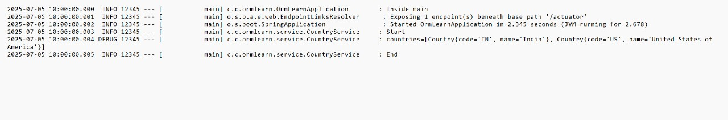 **2.Difference between JPA, Hibernate and Spring Data JPA**

JPA(Java Persistence API):

* JPA is a specification for managing relational data in Java applications. It defines how to map Java objects to database tables and how to perform operations like creating, reading, updating, and deleting(CRUD) data.
* JPA is not a framework, it’s an API that provides a standard way to interact with databases.
* It allows developers to use object-oriented programming concepts with relational databases.

Hibernate:

* Hibernate is an implementation of the JPA specification. It is a popular Object-Relational Mapping framework that simplifies database interactions in Java applications.
* Hibernate provides additional features beyond the JPA specification, such as caching, lazy loading, and more.
* It allows developers to work with Java objects instead of SQL queries, making database operations easier and more intuitive.

Spring Data JPA:

* Spring Data JPA is a part of the Spring Framework that simplifies the use of JPA and Hibernate. It provides a higher-level abstraction for data access, making it easier to work with databases in Spring applications.
* It integrates seamlessly with Spring applications, allowing you to use features like dependency injection and transaction management.